- Navigate to https://jkyog-strapi-staging.up.railway.app/admin/auth/login
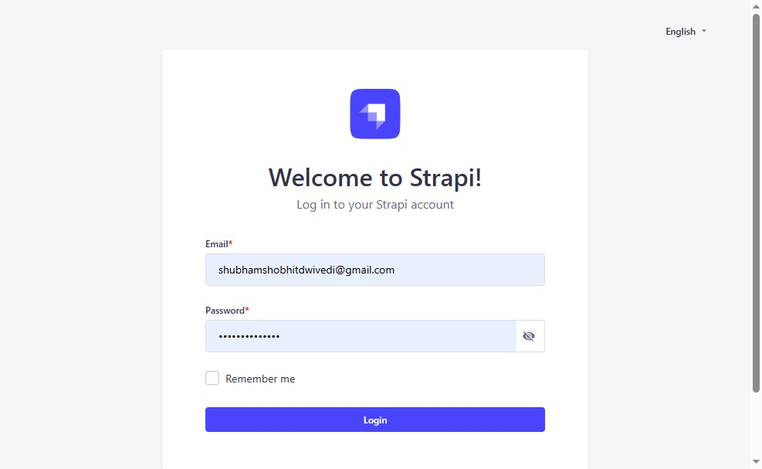
- Click "Login"
- Click "Content Manager"
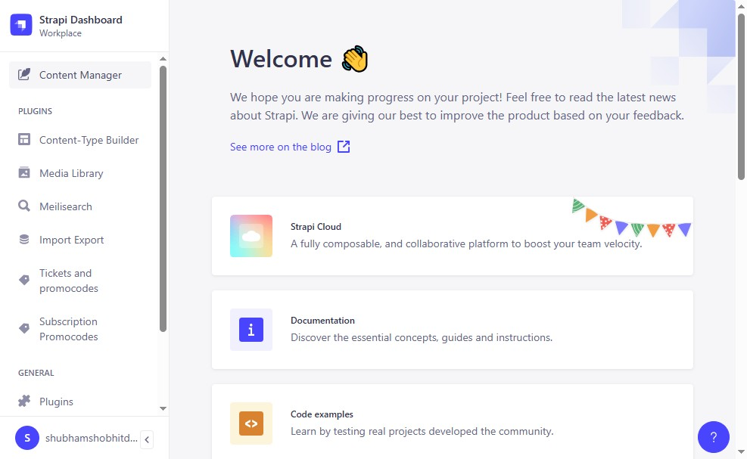
- Click "ContentSearch for a content typeCollection Types39App AnnouncementApp Announcement Content OrderApp ArticlesApp AudiosApp BooksApp ChallengeApp ..."
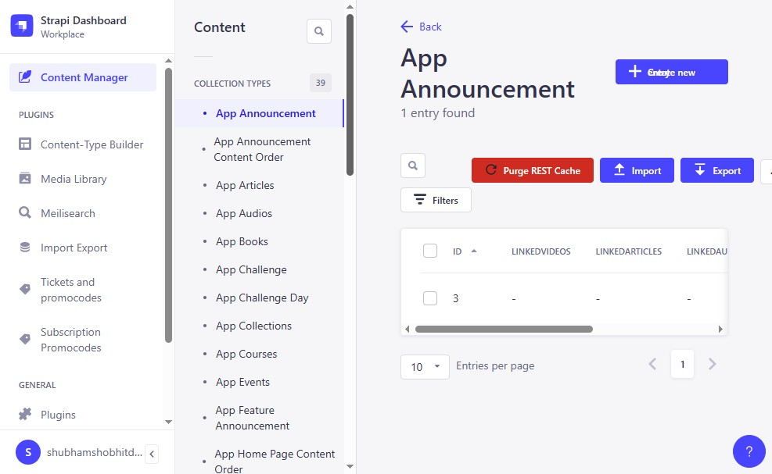

- Click "App LMS Lessons"
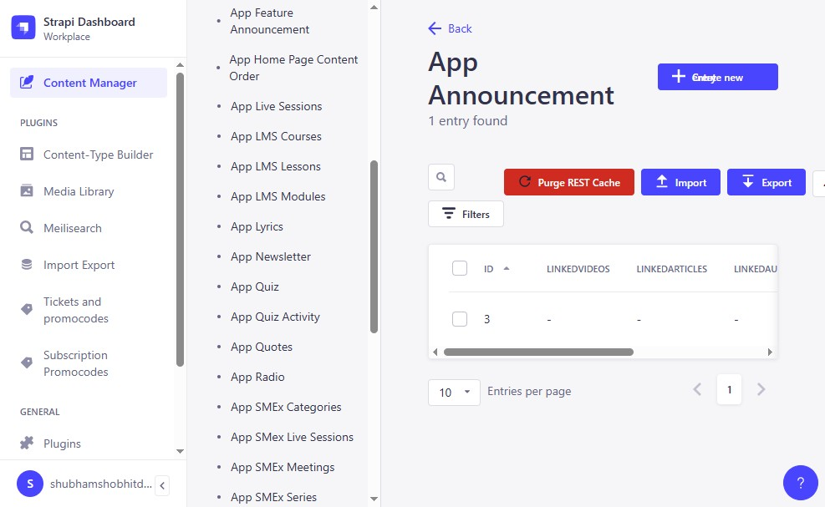
- Click "Who Are We?"
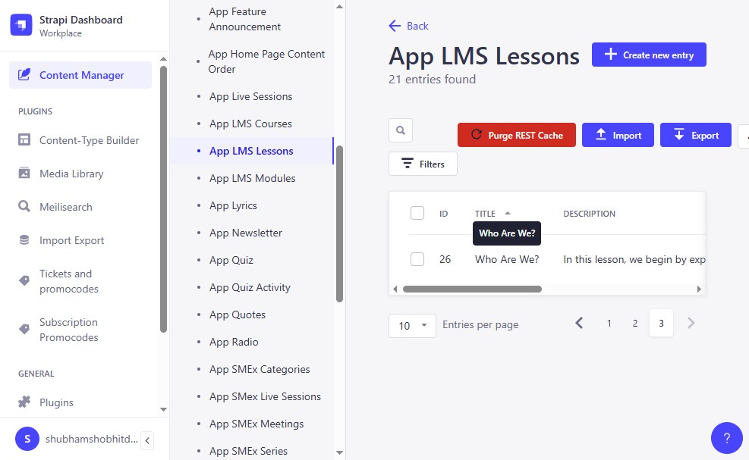

- Click the "Title*" field.
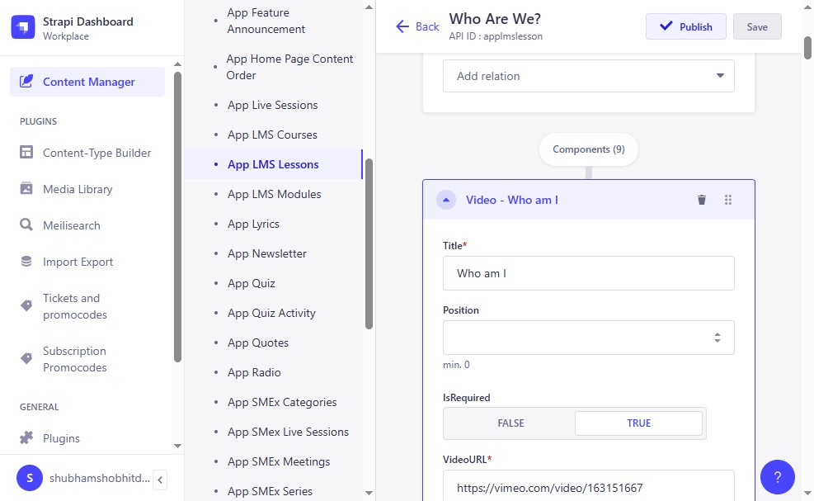
- Click "Save"
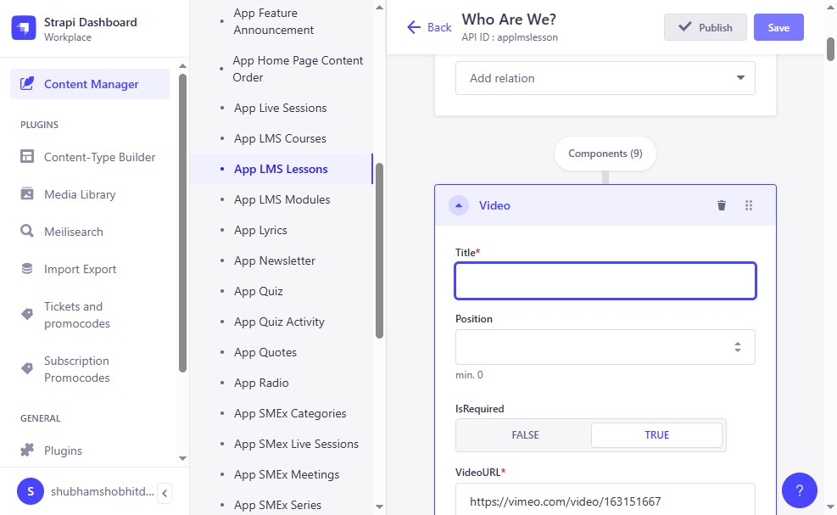

- Click "Publish"
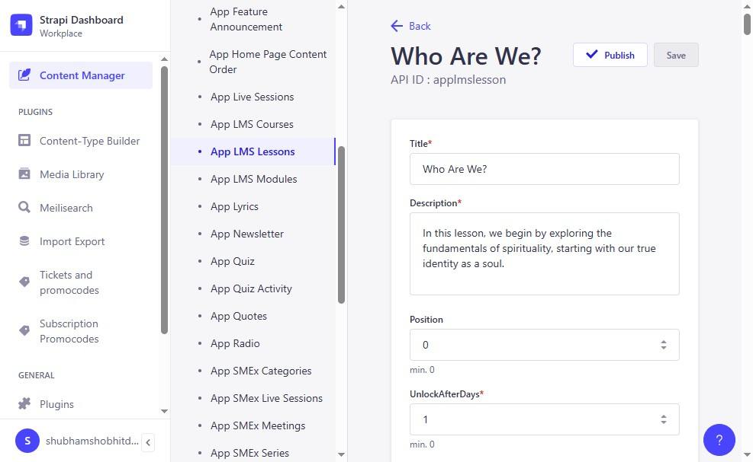

- Click "TitleThis value is required.Positionmin. 0IsRequiredIsRequiredVideoURLDuration*ThumbnailURL"
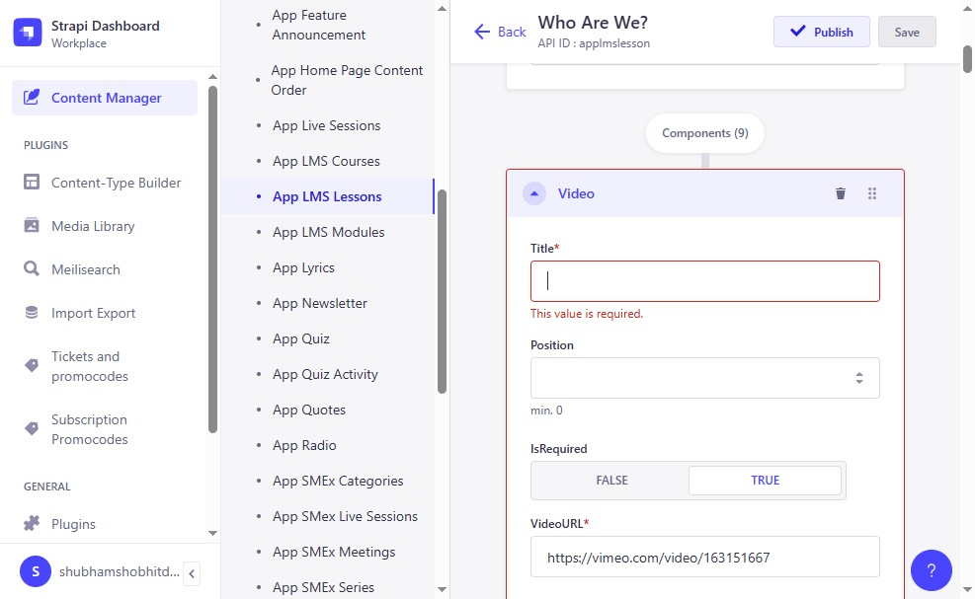
- Click the "Title*" field.
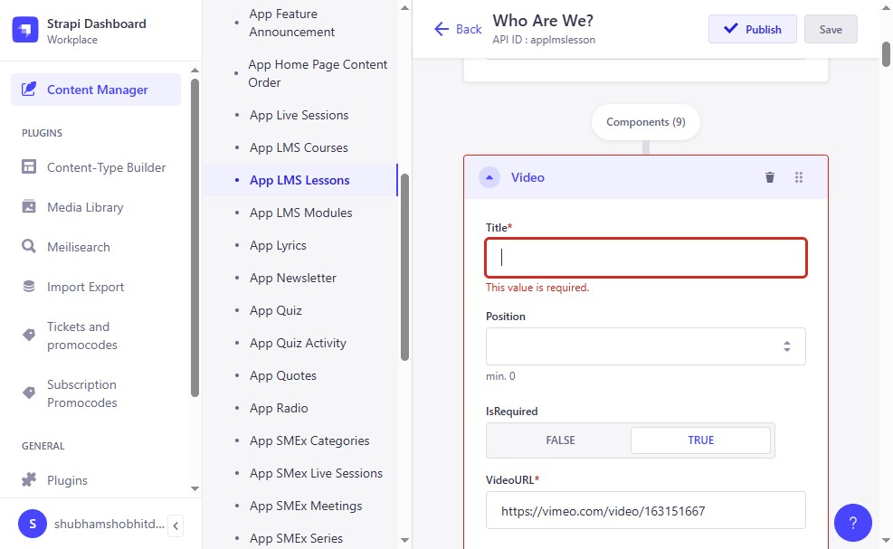
- Type "Who are we"
- Click the "Title*" field.
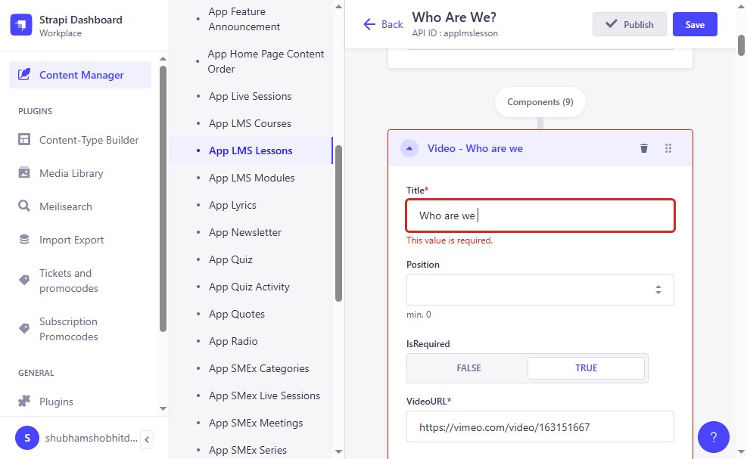
- Click "Save"
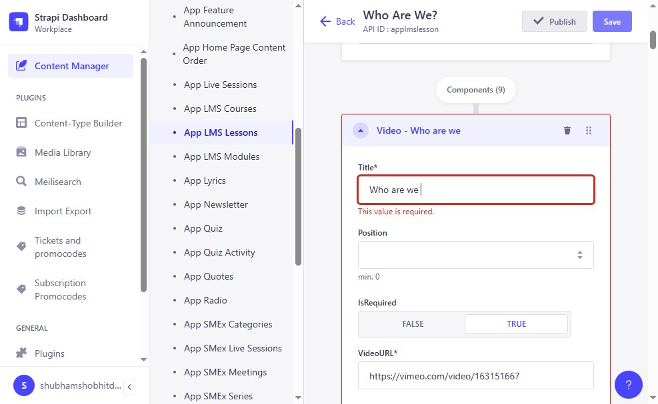

- Click "Publish"
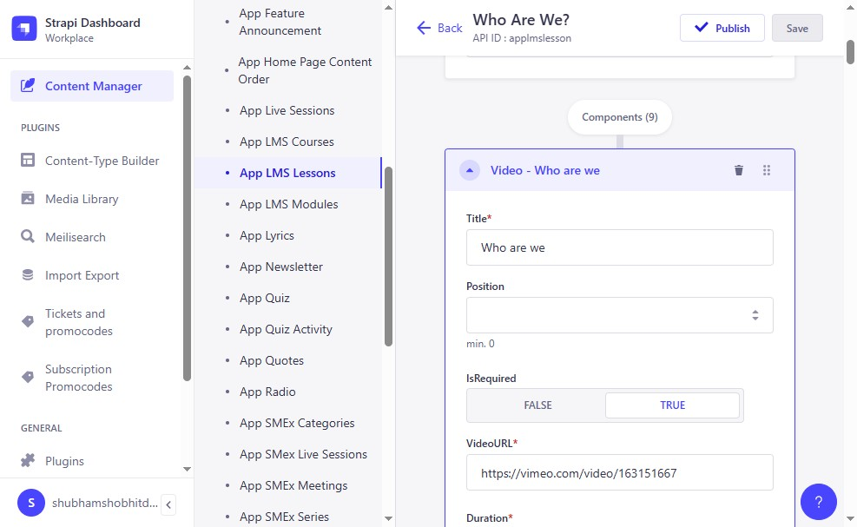
- Click "Skip to contentSkip to contentStrapi DashboardWorkplaceContent ManagerPluginsContent-Type BuilderMedia LibraryMeilisearchImport ExportTickets an..."
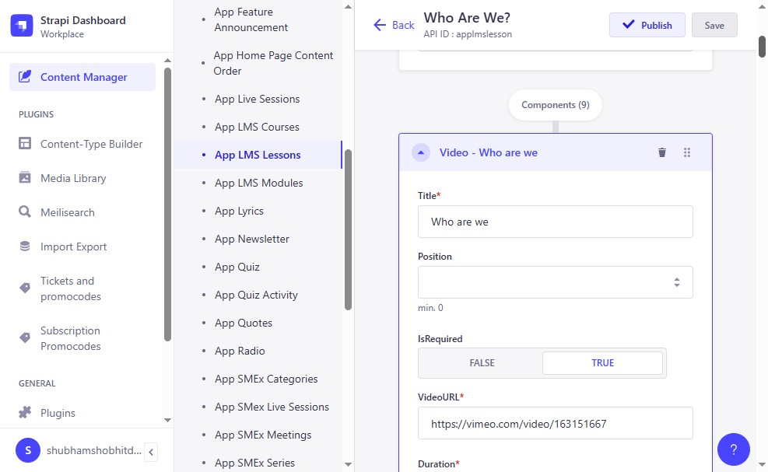
- Click "Publish"
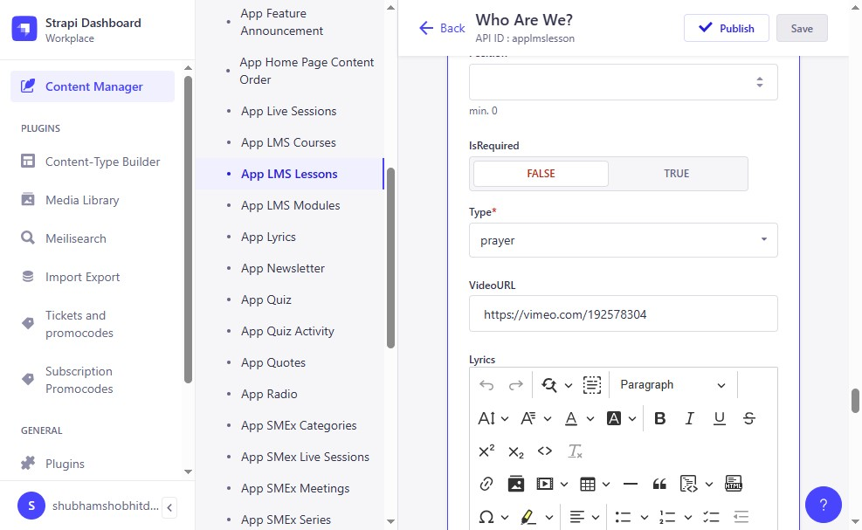
- Click "Publish"
